1. Introduction

Graphitic carbon nitride (g-C3N4) is a polymeric, visible-light-active photocatalyst with a bandgap of ~2.7 eV (~460 nm), that was introduced since 2006. g-C3N4 has become an important material in chemistry, physics and engineering because of its facile, low-cost, environmentally friendly preparation methods with promising stability and good physicochemical properties for use in a wide range of applications [2]. Compared with other semiconductors, g-C3N4 can be easily synthesized by various methods with desirable electrical structures as well as morphologies, and high thermal stability up to 600 C in the air .(Alaghmandfard & Ghandi, 2022)

The g-C3N4 structure has been widely used in many applications, in particular in energy-related applications. Energy consumption to provide electricity and heat will rise to twice its current consumption by 2050, which is mainly due to industrialization, urban absorption and reducing the recombination of electrons and holes by promoting the sep aration of charge carriers. This is mainly due to their suitable band structures. The g-C3N4 structure has been widely used in many applications, in particular in en ergy-related applications. Energy consumption to provide electricity and heat will rise to twice its current consumption by 2050, which is mainly due to industrialization, urbani zation, and population growth. The consumption of fossil fuels, such as natural gas, coal, and oil, should be decreased as their usage results in detrimental environmental impacts . Two remedies are solar energy and photocatalysis . Both require suitable semiconductors such as g-C3N4 with superior activities for different catalytic re actions, such as organic pollutants degradation, H2, and O2 generation by water splitting and CO2 reduction to hydrocarbon fuels . The g-C3N4 can also be used for water disinfection and bacterial control . ization, and population growth . The consumption of fossil fuels, such as natural gas, coal, and oil, should be decreased as their usage results in detrimental environmental impacts . Two remedies are solar energy and photocatalysis. Both require suitable semiconductors such as g-C3N4 with superior activities for different catalytic reactions, such as organic pollutants degradation, H2, and O2 generation by water splitting and CO2 reduction to hydrocarbon fuels. The g-C3N4 can also be used for water disinfection and bacterial control.(Alaghmandfard & Ghandi, 2022)

2. Structure and Properties of g-C3N4

g-C3N4 are a class of two-dimensional (2D) polymeric materials comprising entirely of covalently linked, sp2-hybridized carbon and nitrogen atoms. Carbon and nitrogen have the distinction of various valence states forming bonding; therefore, in g-C3N4, there are diverse of valence bond structures (Darkwah & Ao, 2018)

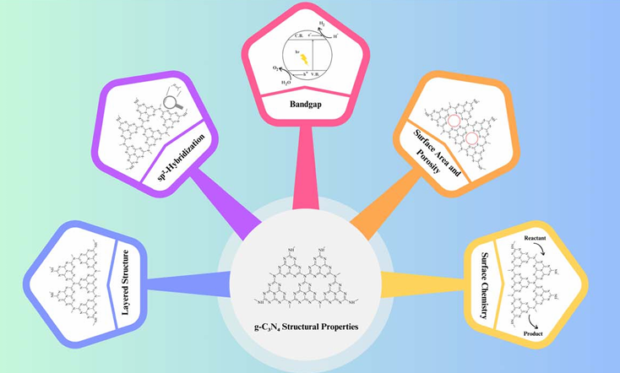

Fig. 1 Structural properties g-C3N4

2.1 Layered structure :

At its core, g-C3N4 consists of stacked layers of carbon and nitrogen atoms arranged in a planar, hexagonal lattice. This layered structure resembles that of graphite, giving rise to its name, “graphitic”. Each layer is composed of tri-s-triazine (C3N3) units, and the layers are held together by weak van der Waals forces. Thislayered conguration providesalargesurface area for potential reactant adsorption and photocatalytic reactions, making g-C3N4 an attractive material for various applications.(Bhanderi et al., 2023)

2.2 sp2-hybridization

The carbon atoms within the g-C3N4 lattice adopt sp2-hybrid ization, resulting in trigonal planar geometry. This sp2-hybrid ized carbon conguration is responsible for the formation of delocalized p-bonds, contributing to the material's excellent electrical conductivity and optical properties. This electron-rich network facilitates charge carrier mobility and separation, which are essential for efficient photocatalysis.(Bhanderi et al., 2023)

2.3 Bandgap Theelectronic

Band structure of g-C3N4 plays a pivotal role in its photocatalytic activity. It exhibits a moderate bandgap typically around 2.7 to 2.8 eV, making it responsive to visible light. Photons with energy equal to or greater than the bandgap can excite electrons from the valence band to the conduction band, initiating the photocatalytic process. The bandgap value allows g-C3N4 to harness a substantial portion of the solar spectrum, rendering it effective for solar-driven applications.

2.4 Surface area and porosity

The layer-by-layer structure of g-C3N4 results in a high surface area, providing ample sites for reactant adsorption and subse quent photocatalytic reactions. The interlayer spacing between g-C3N4 layers can be tuned to create mesopores and micropores, further enhancing its surface area and porosity. These struc tural features facilitate efficient mass transport and reactant accessibility, promoting photocatalytic efficiency.(Bhanderi et al., 2023)

3. Synthesis methods

3.1 Thermal polymerization : One of the most widely employed methods for g-C3N4 synthesis is thermal polymerization of low-cost precursors, such as melamine, urea, cyanamide, dicyanamide, thiourea, cyanuric acid etc. This process typically involves the heating of these precursors at moderate temperatures (around 500–600 °C) under inert gas atmospheres (Fig. 2). The thermal polymeriza tion route generates a layered g-C3N4 structure with a high surface area, making it suitable for various photocatalytic applications. The method's simplicity and cost-effectiveness have contributed to its popularity.

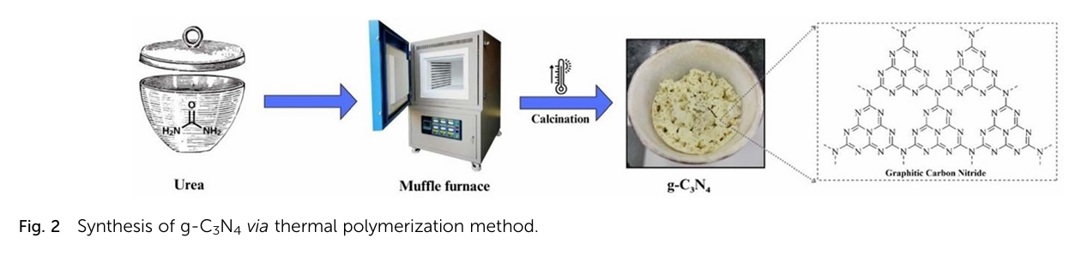

4. Applications

4.1 Hydrogen production through water splitting

The efficient utilization of solar energy for water splitting holds the key to clean hydrogen production. g-C₃N₄'s bandgap aligns well with the solar spectrum, enabling photocatalytic water splitting by absorbing photons and generating electron-hole pairs, producing hydrogen fuel—a step toward a hydrogen-based economy. (Bhanderi et al., 2023)

Han et al**.** synthesized g-C₃N₄/Ag composites using precipitation–calcination (DeCNexAg) and annealing (ZeCNexAg). The DeCNexAg **with** 5% Ag₂CO**₃** showed 4.6× higher hydrogen production than ZeCNe5% Ag due to metallic Ag and additional active sites, enhancing charge separation and transfer. Their study highlighted the role of local surface plasmon resonance (LSPR**)** and the Ag–g-C₃N₄ interaction in improving hydrogen production. (Bhanderi et al., 2023)

Samaniego-Benitez et al**.** developed a g-C₃N₄/NiS hybrid photocatalyst via thermal decompositionand hydrothermal methods, achieving 1230 mmol H₂/h, outperforming g-C₃N₄ and TiO**₂**. The hybrid’s kinetic constant (307.1 h⁻¹) indicates improved activity due to reduced electron-hole recombination in its mixed-phase structure. (Bhanderi et al., 2023)

Li et al**.** created g-C₃N₄/Ag/AgBr heterojunctions using solvothermal technology, enhancing photoresponse and catalytic efficiency with dimensional nanosheets. (Bhanderi et al., 2023)

Zhu et al. designed a Mn₃O₄/g-C₃N₄ p–n heterojunction via in situ growth, significantly boosting light absorption and achieving a hydrogen evolution rate of ~2700 mmol g⁻¹ **h⁻¹** (λ > 420 nm), stable over **15 hours**. The system showed high EQEs and catalyzed overall water splitting (H₂:O₂ = 2:1) under simulated sunlight.(Bhanderi et al., 2023)

4.2 Water purication and treatment

One of the most critical applications of g-C₃N₄ is in water purification, where its photocatalytic ability enables the degradation of organic pollutants and the removal of toxic heavy metals like chromium and lead. This sustainable approach enhances water remediation, ensuring cleaner resources. (Bhanderi et al., 2023)

Ding et al**.** synthesized a magnetic graphene oxide (mGO)and g-C₃N₄ nanocomposite(mGCN) for U(VI) photoreduction in wastewater under visible LED light. The composite exhibited high selectivity, reusability**,** and an extraction capacityof 2880**.**6 mgg⁻**¹**, converting U(VI) to metastudtite. This research advances photocatalytic uranium wastewater treatment. (Bhanderi et al., 2023)

Gnana Prakash et al. developed g-C₃N₄/ZnO nanocomposites using melaminepyrolysis and hydrothermal methods for crystal violet degradation. The nanocomposite achieved 97% degradation efficiency and a 1.4× higher rate constant than ZnO and g-C₃N₄ alone, with excellent stability over multiple cycles. Its superior performance is attributed to enhanced visible light absorption and a heterojunction structure, facilitating efficient charge separation. (Bhanderi et al., 2023)

Kumar et al. synthesized porous g-C₃N₄ (p-g-C₃N₄) via chemical protonation, enhancing dye degradation under sunlight. The protonation induced a blue shift in the optical absorption edge, increasing the surface area and exposing more active sites for photocatalysis(Bhanderi et al., 2023)

4.4 Solar fuel cells

g-C₃N₄ plays a vital role in solar fuel cells, enabling hydrogen generation and energy storage through photocatalysis. These fuel cells provide a sustainable alternative to fossil fuels, reducing greenhouse gas emissions while supporting clean energy initiatives.(Bhanderi et al., 2023)

5. Antimicrobial Analysis of g-C₃N₄

Graphitic carbon nitride (g-C₃N₄) nanosheets exhibit promising antimicrobial properties due to their ability to generate reactive oxygen species (ROS) under visible light irradiation. These ROS, including superoxide radicals (O₂⁻), singlet oxygen (¹O₂), and hydroxyl radicals (OH⁻)**,** induce oxidative stress, leading to cell membrane damage and metabolic disruption in pathogens.

g-C₃N₄ nanosheets have shown antibacterial effects on E. coli, Staphylococcus aureus, and Pseudomonas aeruginosa under visible light. Their potential against oomycete pathogens like *Phytophthora capsici* has been explored, revealing strong anti-oomycotal activity.

Photocatalytic generation of ROS disrupts cellular components.Direct contact with g-C₃N₄ nanosheets leads to membrane damage**,** metabolic inhibition, and impaired reproduction in microbes.

6. Contact angles of g-C₃N₄

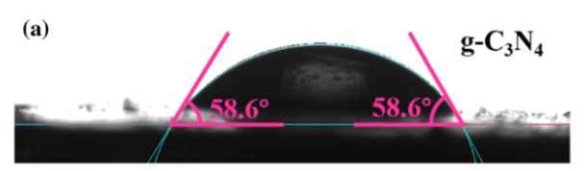

Fig 3 Contact angles of g-C₃N₄

Alaghmandfard, A., & Ghandi, K. (2022). A Comprehensive Review of Graphitic Carbon Nitride (g-C3N4)–Metal Oxide-Based Nanocomposites: Potential for Photocatalysis and Sensing. *Nanomaterials*, *12*(2). https://doi.org/10.3390/nano12020294

Bhanderi, D., Lakhani, P., & Modi, C. K. (2023). Graphitic carbon nitride (g-C3N4) as an emerging photocatalyst for sustainable environmental applications: a comprehensive review. *RSC Sustainability*, *2*(2), 265–287. https://doi.org/10.1039/d3su00382e

Darkwah, W. K., & Ao, Y. (2018). Mini Review on the Structure and Properties (Photocatalysis), and Preparation Techniques of Graphitic Carbon Nitride Nano-Based Particle, and Its Applications. *Nanoscale Research Letters*, *13*. https://doi.org/10.1186/s11671-018-2702-3